The NeoSoniX handpiece
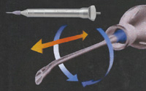
The NeoSoniX handpiece from Alcon is the first to combine sonic, nonlinear oscillation with linear ultrasound.
The NeoSoniX handpiece makes surgery faster and safer by allowing the tip to oscillate and rotating. The NeoSonix handpiece combines traditional ultrasound energy with an oscillatory motion of the phaco tip (±2° oscillation at 100Hz). Soft nuclei can be removed with NeoSonix alone and the NeoSonix handpiece reduces the phaco powerused with other lenses. No change in technique or incision size is needed. There is a preset level of ultrasound at which the oscillation commence. The amplitude varies between 0-100% of the total arc. As the ultrasound energy increases, the amplitude of vibrations increases. The handpiece is slightly larger and heavier than conventional handpieces and the vibrations are palpable. The sonic oscillations can be switched off with the NeoSonix handpiece. With the AdvanTec software upgrade (required to operate the NeoSoniX handpiece), you can use oscillation only, linear ultrasound only, or both at once. AdvanTec also lets you control the amplitude of the oscillation and the threshold of ultrasound power at which it engages.
Having this option accomplishes two things:
- First, it helps you control how and when occlusion occurs. During sculpting, for example, you can set the threshold to 0%; NeoSoniX comes on immediately with the ultrasound, helping to prevent occlusion. If you want occlusion during chopping or segment removal, you can set the threshold onset to delay until you reach a specific level of ultrasound power.
- Second, when the tip is oscillating, the ultrasonic effect is distributed across the face of the nuclear material. This increases the efficiency of energy delivery and disruption of the natural micro-fissures in the lens material.
Other advantages of the NeoSoniX handpiece include:
- Some cataracts can be removed using oscillation alone. This reduces thermal energy as much as 99.7% compared with conventional ultrasound.
- The NeoSoniX handpiece can be used with any LEGACY and INFINITY phaco tip, except a Mackool tip.
- This technology works to your advantage regardless of the phaco technique you prefer to use.
The bottom line? The NeoSoniX handpiece allows you to perform more efficient phaco using less energy. (This has been confirmed in ongoing studies being conducted by several surgeons.)

NeoSonix’s Features and Advantages

Secure - Low frequency funtcion has negliglible heat impact.
Effective – Secondary method of cutting.
Economical - A new instrument’s procurement is less investment.
At a quick pace learn – The new technology acquire next door to immediately.
Many-sided – Every until now STTLegacy and INFINITI phaco tip can be used.
Tolerance – Less phaco power in case of every hard and every soft ocular nucleus

Features: | TurboSonic | NeoSoniX
Ultrasound: | yes | yes
Oscillation: | no | yes
Length: | 162.5mm | 157.4mm
Mass: | 90g | 130g
Diameter: | 12.7mm | 16.76mm
Irrigation: | External irrigation line | coaxial
House: | stainless steel | titanium

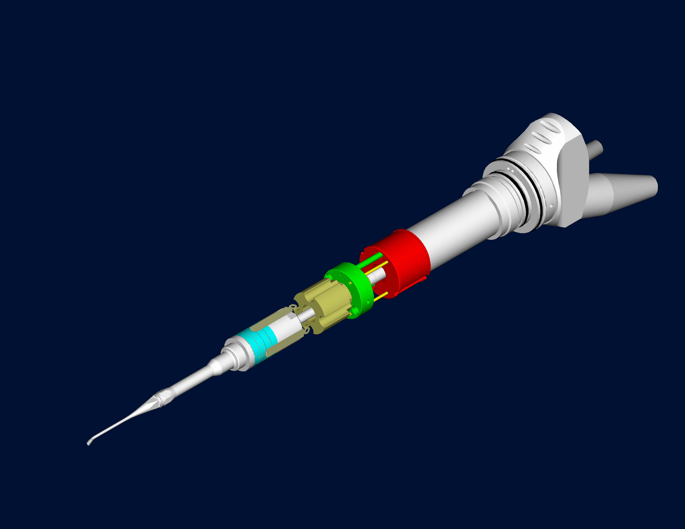
Sonic
Ultrasonics
Oscillation
Ultrasound movments

